Mobile Robotics

Homework Assignment 1

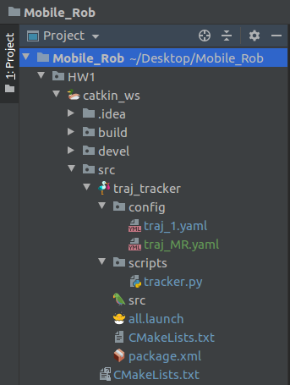
1. The process of the source code running
The file structure of the assignment is as the right figure:
We will run the command $ roslaunch traj_tracker all.launch to run the launch file. The all.launch file will run /turtlesim1 node, run /traj_tracker/tracker node, and import parameter “trajectory_discription” from the file traj_1.yaml.

The nodes in the ros work as the following figure:
The node /turtlesim1 creates the turtlebot simulation environment. The node /tracker subscribe the topic /turtle1/pose to obtain the current pose of the turtlebot, then use it together with the desired trajectory “trajectory_description” to calculate the control output (velocity, angular velocity) and publishes to the topic /turtle1/cmd_vel. In the same time, the error is calculated by the node /tracker and send to the service /turtle1/set_pen as color encode.
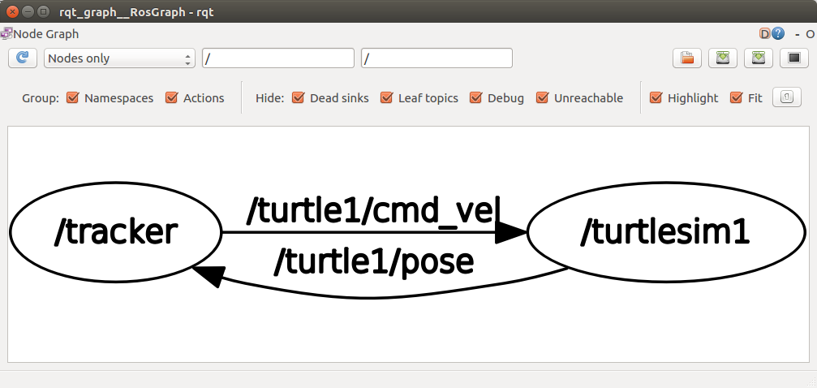

2. The results
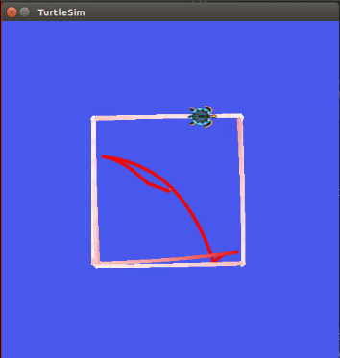
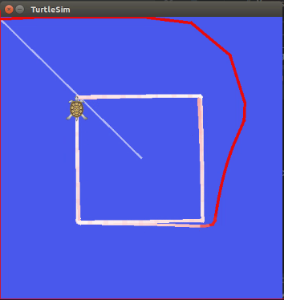
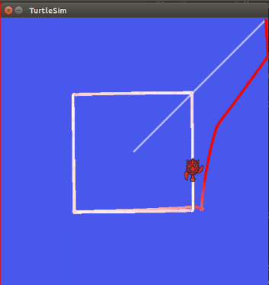

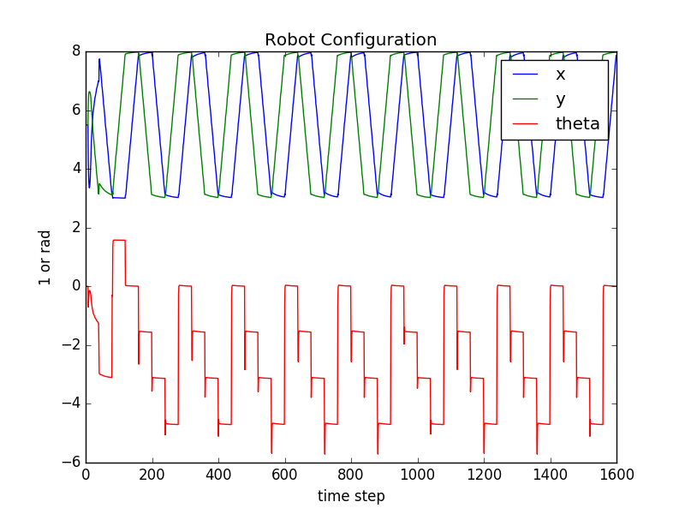
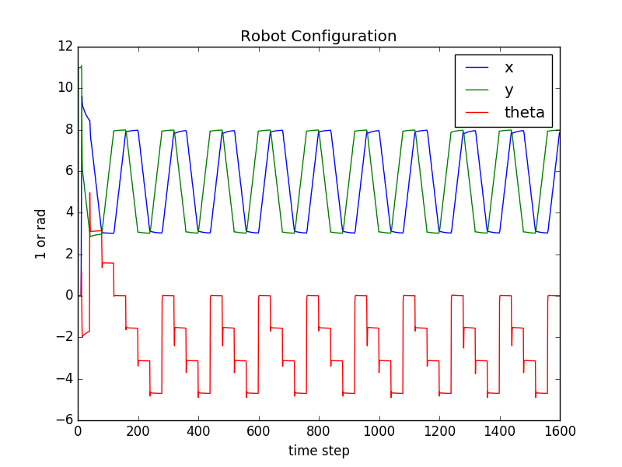
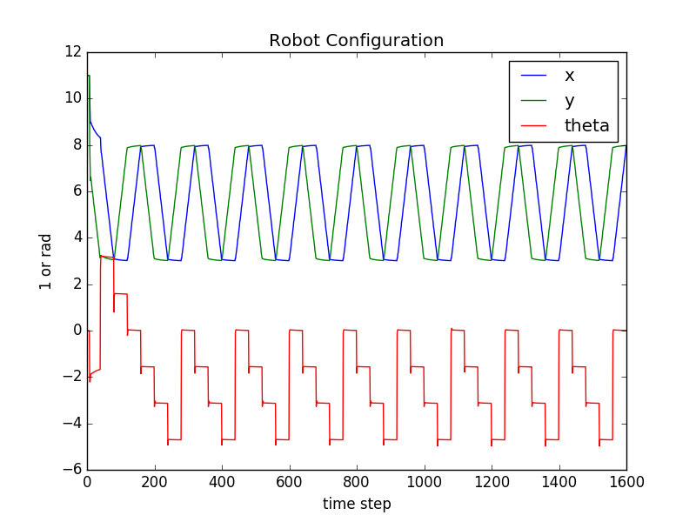

center
top-left
top-right
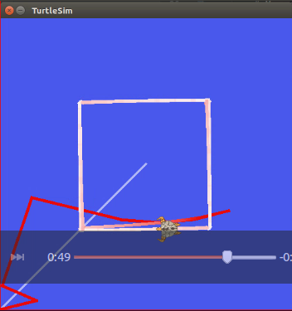
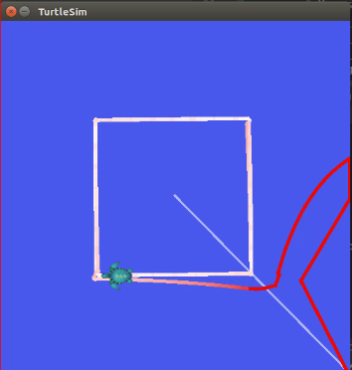
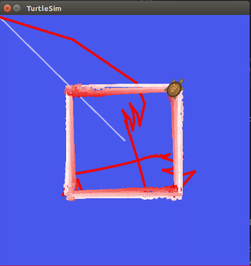

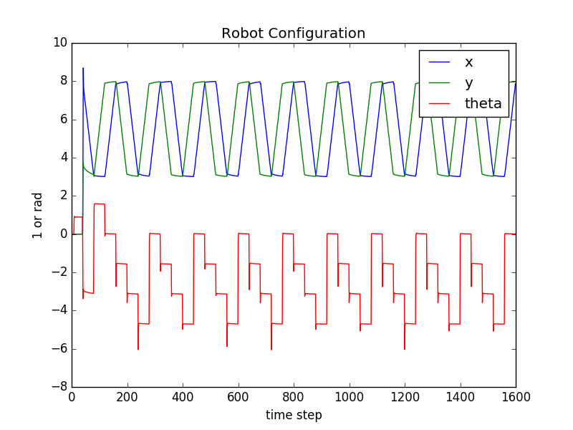
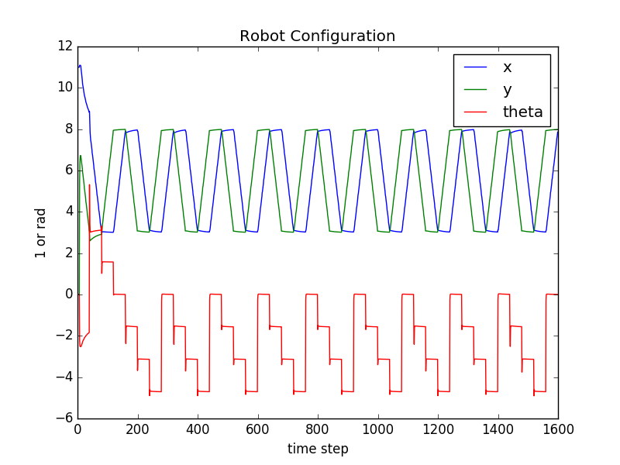
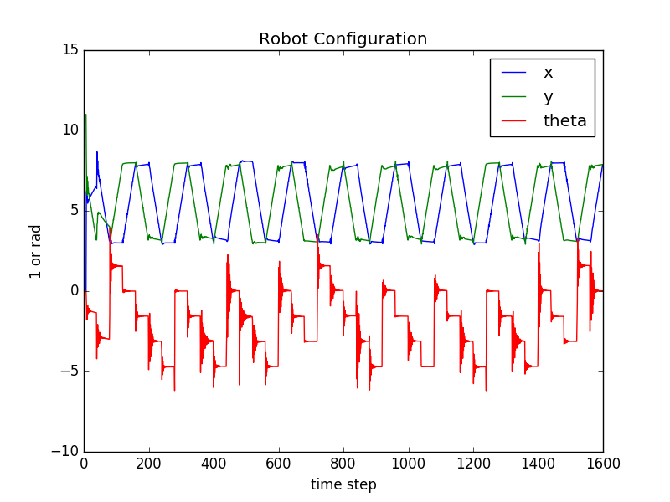

bottom-left
bottom-right
param-
set-1
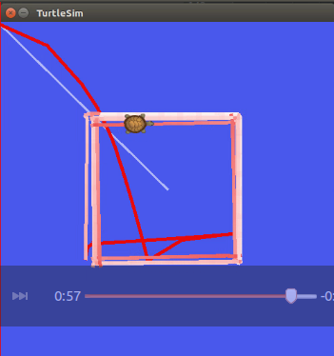
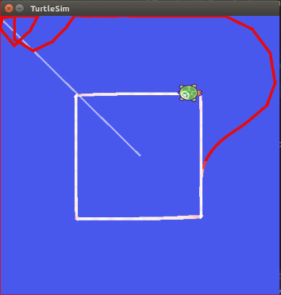
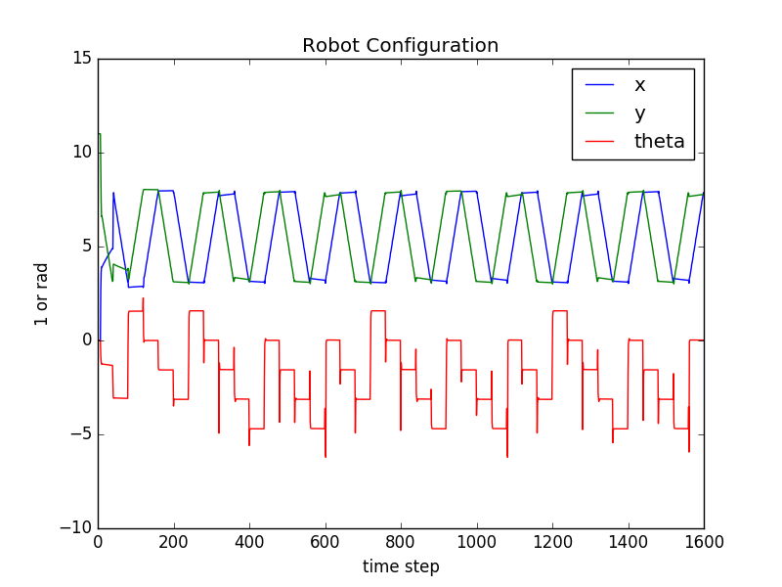
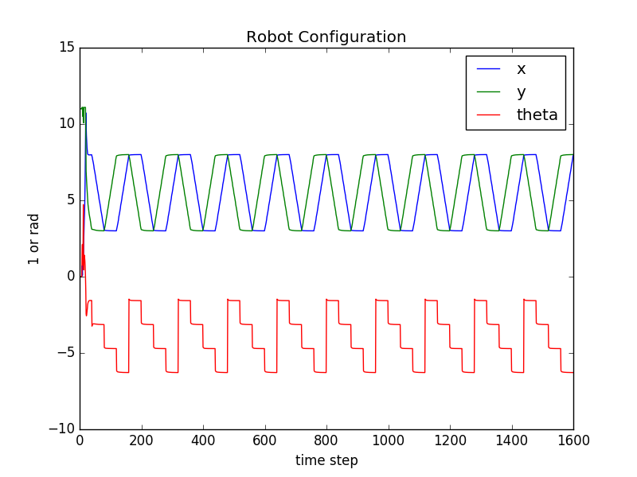
param-
set-2
param-
set-3
‘M R’ trajectory
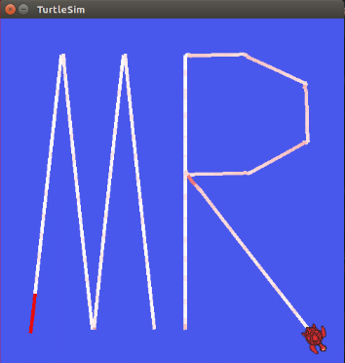

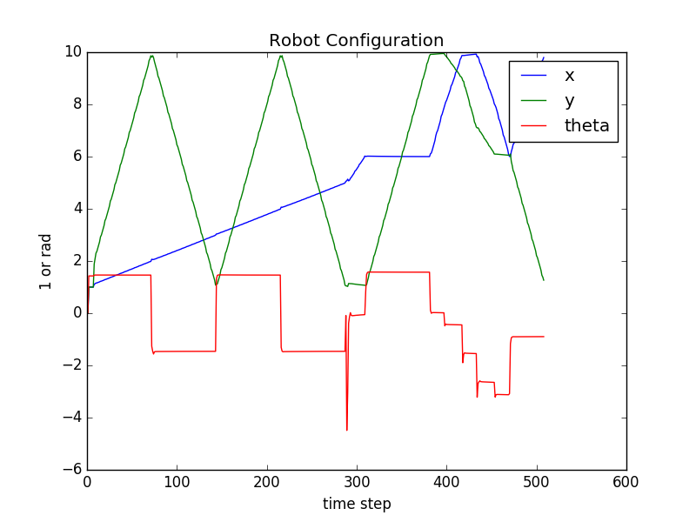

The tracker performs good after para meter tuning. However, there always has overshot between the start point and the trajectory. This may due to the control method is simple.
From parameter set 1, 2, and 3 we can see that set 1 lead to large overshot, set 2 cannot converge to the trajectory fast, set 3 takes long time to converge.

3. The parameter setting
In this controller, the parameter is set epsilon = 2.5, a = 5.5. Thus k1, k2, k3 can be calculated by the formula given in the class. Use epsilon/a parameter set is more stable and convergences faster than k1, k2, k3 set for the controlloer.

